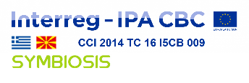 SYMBIOSIS – CN1 – SO1.2 – SC017
The project is co-funded by the European Union and
by the National Funds of the participating countries

SYMBIOSIS PP5
Movement for the environment MOLIKA DOM Bitola

Name and address of the Contracting Authority:
Project "Symbiotic networks of bio-waste sustainable management" – SYMBIOSIS
Co-funded by the European Union and by the National Funds of the participating countries under the INTERREG IPA Cross-border Cooperation Programme Greece – Republic of North Macedonia 2014-2020
Reference number of Subsidy Contract: SYMBIOSIS – CN1 – SO1.2 – SC017
Tender Issued by the Movement for the Environment MOLIKA DOM Bitola (PP5)

Title of the tender: PRINTING SERVICES

Reference number: SYM_PP5_TD.02/2019

LIST OF INVITED TENDERERS

- DOO BARBI Bitola
- GRAFO PROM DOOEL Bitola
- IRIS PRINT DOO Struga
- Any other interested organization is invited to apply, following publishing our following the publishing of our invitation to tender for a service contract: printing services, published on the website of the Movement for the Environment MOLIKA DOM Bitola.

