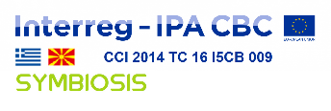 SYMBIOSIS – CN1 – SO1.2 – SC017
The project is co-funded by the European Union and
by the National Funds of the participating countries

SYMBIOSIS PP5
Movement for the environment MOLIKA DOM Bitola

Name and address of the Contracting Authority:
Project "Symbiotic networks of bio-waste sustainable management" – SYMBIOSIS
Co-funded by the European Union and by the National Funds of the participating countries under the INTERREG IPA Cross-border Cooperation Programme Greece –Republic of North Macedonia 2014-2020
Reference number of Subsidy Contract: SYMBIOSIS – CN1 – SO1.2 – SC017
Tender Issued by the Movement for the Environment MOLIKA DOM Bitola (PP5)

Title of the tender: BROADCASTING OF CAMPAIGN VIDEO & AUDIO MATERIAL

Reference number: SYM_PP5_TD.04/2020

LIST OF INVITED TENDERERS

- Production, Trade & Services CONCEPT PRODUCTION import-export DOOEL Bitola
- Services and Trade PRAG 33 import-export DOOEL Bitola
- DOOEL ZAGA Production Bitola
- Any other interested organization is invited to apply, following publishing our following the publishing of our invitation to tender for a service contract: Broadcasting of campaign video & audio material published on the website of the Movement for the Environment MOLIKA DOM Bitola.

